PGEE EXAM:
1. Monkey climbing wall of 40m. Each min climbs 5m and falls down 3m. At what time will it first reach top?
2. It is estimated that 50% of emails are spam emails. Some software that has been applied to filter can detect 99% of spam emails, and the probability for a false positive (a non-spam email detected as spam) is 5%. Now if an email is detected as spam, then what is the probability that it is in fact these spam emails before they reach your inbox. A certain brand of software claims that it is a non-spam email? ANSWER: 5/104
3.|x-7|<1 find range of X
4. Reema and Seema were facing each other in evening. Reema’s shadow was falling at her right. What direction was seema facing?
5. Find value of ‘?’ where logic was squaring and adding first two no. to get third one.
6. Initial value of bacteria density, decaying rate, time was given. Find density after 5 yrs?
7. 1st January 2029 is Monday, which month will have the same calender as of January
from the same year?
July B.August C.November D.October
8. 3,6=45 2,4=20 1,7=?
9. A invested Rs. x, B invested Rs Y then after 4 months A removed 4000 and B added
4000. Then after 2 month C invested 25000. Who get max share
10. A said to B that the girl is the daughter of the brother in law and mother of my frnd.
Relation between A’s frnd and that girl?
11. Find unfolding of a given 3d shape? (Prism was give with square base)
12. Which of the following cannot be the sum of two or more consecutive positive integers?
(don’t remember options)
13. If there is an error of a% in measuring the edge of a cube, then % error in surface area?
14. 30x^(2) + 11x + 1 = 0 and 42y^(2) + 13y + 1 = 0, then which option is correct?
A. x>y B. x<y C. x<=y D. x=y
15. A container contains 40 litres of milk. From this container 4 litres of milk was taken out and replaced by water. This process was repeated further two times. How much milk is now contained by the container?
16. If 2, 3, 6, X, 45, 157.5 what is the value in place of ‘X’.

1. 2 Questions like given 4ltr and 3ltr beakers and you have to measure
2ltr in 4ltr beaker find minimum no of steps ( only 3 operations
allowed Fill, Empty, Transfer).
Same question given 5ltr & 8ltr beaker measure 4ltr in 8ltr beaker.
2. 80% South Indians like tea, 50% likes coffee, how many minimum
likes both tea and coffee ?
3. A lady in 32 ft deep well. She climbs 4 ft at once but she slips 3 ft
back, minimum steps she needs to come out of the well ?
4. A ball if dropped from some height then it will again jump 10% of the
initial height. If we drop it from 45 ft, then how many jumps it will take
(or maybe how much distance it covered) before coming to rest.
5. A man wants to plant trees in a square field, but he left with 10 trees,
so he increased 1 step from each row, then he had to buy 13 more
trees, how many trees did he planted ?
6. 44*31 in a base is 1031, Then 111 is equivalent to in decimal ? (I
missed the exact numbers given).
7. S1 & S2 eats in 65 days
S1 & S3 eats in 40 days
S2 & S3 eats in … days
In how many days they all finish it ?
8. 12 Questions on conclusion based.
9. 5 Questions on comprehension.
10. 5 Questions on reasoning (Odd one out, next sequence etc).
30. There are 5 friend ABCDE and 3 subject chemistry biology
history
E took history
B and D will take same subject
C will not take same subject as A.
How many combinations are possible ?
33. 56 books are to be distributed among 10 standard students of
class V and VI
Class V students takes 5 books
Class VI students takes 6 books
How many students of V and VI are there
>a monkey climbing up a pole ascends 10 metres and slips 2 metres in alternate minutes if the pole is 63 metres high how long will it take to reach the top of the tree?
a.14 min 42 sec b.15 min 20 sec c.16 min 40 sec d.12 min 40 sec
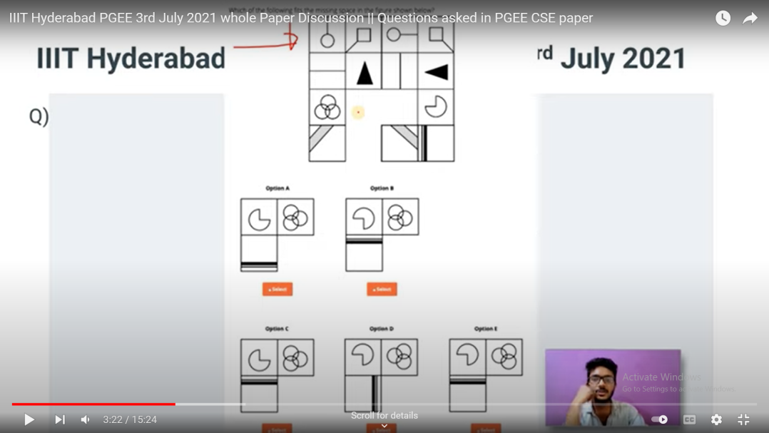
>1st jan 2021 is Monday ,which month of 2021 will have same calendar as jan …… a.sept, july,oct,nov

1. No of ones in binary representation of (3*2048 + 15*512 + 5*16 + 3).
2. Charact. Equation of SR notch using NOR gates.
3. One question of Calendar.
4. What Bakery Algorithm improves: (a). throughput (b). latency (c). both (d). None
5. “COMPUTER” total arrangements possible with first and last character consonants only.
6. Implementation of queue using linked list and array. (a) O(1) to dequeue or enqueue using LL. (b) O(1) to dequeue or enqueue using Array. (c). Both a and b (d) None.
7. One question on insertion of elements in Empty AVL tree.
8. One question on h(k) = kmod7 (using Quadratic Probing) with values given. Guess the array after element insertion.
9. X% error in measuring side of a cube. What would be the % error in measuring surface area of cube.
10. 40ft tall tower. If a monkey climbs 5ft and slides 3ft. How much steps to reach at top of building.
11. One question from Number series.

16. Few Questions from Spatial Aptitude

18. Cloth: Fabric :: sound then (a)music (b)pitch (c)decibel (d)vibrations

19. 5 basic comprehensions were given. Each Comprehensions consists of 3-5 questions.

23. A line segment AB is given of length 2a and point is marked on this line say “P”. Find the probability such that the area of rectangle formed from AP and PB is (a^2)/2.

2. There r two large vessels filled with a litre of apple juice and grape juice. A tablespoonful of apple juice is poured into grape juice vessel.Then out of the mixture(apple and grape ) one tablespoonful of the mixture is poured into apple juice vessel Which of the following options are true
A apple juice is more in the grape juice compared to grape juice in apple juice
B grape juice is more in apple juice than compared to grape juice in apple juice
C Both r same
D Depends on the size of tablespoonful.
6 AABCD,________,ABCCCCD,ABCDDDDD fill in the blanks
Maths 9 2,7,14,23,__,47
Maths integration from -3 to 3 of |x +1|dx A 5 B 10 C 15 D 20
12. Suppose there is a 2 digit no ending with d such that the product of the digit is same as the sum of the digits then the value of d is A 5 B 9 C none of the above D all the above
15. Two tricky comprehension 5 qs each
5. many questions on logical reasoning.
PGEE 2016 Paper 1: Aptitude (45 questions, MCQ) 90 minutes, questions had multiple answers. 1. 2 english comprehensions each with 5 questions, no antonym and synonyms. level was good (not easy at all). 2. 3 questions on pnc, 3 questions of probability.
1)if there are 5 Men and 2 women find the number of ways in which these people can be made to sit around in a table(clockwise and anticlockwise seprately) with the two women not sitting with each other options : 6!/2! 6!x2!240480
2) 2-3 problems on time,speed,distance(Trains and other)
3)Allegation problem
4)2 RC(Too long) having 6 ques each

5)2-3 paragraphs and options were given. Asked type: which of the following sentence weakens/strengthens the argument 6) LCM of two nos is 280 and their ratio is 7:8. Guess these numbers. 7)2-3 problems on time and work
9) problem on -difference between simple and compound interest.
10>Q.1 Sum of 1/4 + 1/9 + 1/16 .... is a. less than 1b. greater than 1c. equal to 1d. (dont remember)*Akshay mane
11>. If 3 cards are drawn from a pack of 52 cards in how many ways it is possible that all three cards are of different types. Options : a. 53C13b. 13*12*11c. 4*(13^3)and 1 more
13>1) find the least value of 3^x+3^(-x)a)2b)1c)0 4>10)if a finishes the work in 15 days and b finshes the work 10 days and if both work for 5 days and then b left the job then find the days for which a must work to finish the piece of work
15>trigonometry question: if shadow of a building when sun elevation is 45 degree is 20 m larger than that when sun's elevation is 60 degree..dont remember the option, very big options including square root 3..
16>if a=16*sq root2 and b=2*sq root2 , find log b(base a)? dont remember options .. 17> if a man can do a work in 15 days and a woman can do it in 20 days , after doing for 5 days woman leaves the work, in how many days man will complete the work. 18> in apti 2 ques n geometry relatd to circle was dere.
19)There are 6 locks and 6 keys .In how many attempts you can find out which lock matches which key
20>7)find the contrapostive of a sentence sentence was like this .--> if i know the rules and i am not overconfident then i will won the game .. (not sure of this sentence)
There was a question that given a perimeter p,which one of these has least area? 1.Equilateral triangle 2.Right angled isosceles triangle 3.Circle 4.Square 5. Hexagon So whats the correct answer ? find side or radius in terms of perimeter p, then find area and compare. example: for circle 2.pi.R=P.... R=P/(2.pi)....area= pi.(R^2)=[pi/(4.pi*pi)].(P^2)....we can find this for all and compare the result
Some questions were like find out wrong word, recognize pattern(total around 5 questions from these topics.)

2017
Let X be a length used to make three sides of a rectangle. Area of rectangle will be:
A. X2/9X2/9
B. (X−a)2/4(X−a)2/4
C. (X+a)2/16(X+a)2/16
D. None of the above
Consider 3 card one having both side painted red another having both side printed black and last having one side black and another side red, 3 cards are put in a hat and are mixed properly, now one card in picked and put down on table, its face up color is red what is probability that another side will be black.

